ISSN: 2716-9189 E-ISSN: 2676-1750 Journal of Studies in Language, Culture, and Society (JSLCS). (00) 00, 0000. (PP )
Received: ………. Accepted: ……………. Published: ………..

[THE TITLE OF THE ARTICLE: Times New Romans, Upper case letters, Font 16, No Line Spacing]

Author Author ²
¹ Full affiliation (Country), Times New Roman 10
email@adress
² Full affiliation (Country), Times New Roman 10
email@adress

Abstract [Times New Roman 11 Bold]
Insert the abstract here (do not go beyond 250 words) An abstract is a short resume that reports the aims and outcomes of the research study to enable the readers know exactly what the paper is about (Times New Roman, Size 11, No line spacing) . Insert the abstract here (do not go beyond 250 words) An abstract is a short resume that reports the aims and outcomes of the research study to enable the readers know exactly what the paper is about (Times New Roman, Size 11, No line spacing) . Insert the abstract here (do not go beyond 250 words) An abstract is a short resume that reports the aims and outcomes of the research study to enable the readers know exactly what the paper is about (Times New Roman, Size 11, No line spacing). Insert the abstract here (do not go beyond 250 words) An abstract is a short resume that reports the aims and outcomes of the research study to enable the readers know exactly what the paper is about (Times New Roman, Size 11, No line spacing) . Insert the abstract here (do not go beyond 250 words) An abstract is a short resume that reports the aims and outcomes of the research study to enable the readers know exactly what the paper is about (Times New Roman, Size 11, No line spacing) . Insert the abstract here (do not go beyond 250 words) An abstract is a short resume that reports the aims…
Keywords: Keyword 1 ; keyword 2 ; keyword 3 ; keyword 4 ; keyword 5 (keywords should be listed in an alphabetical order and in small letters keeping just the first key word or any Proper noun keyword in capital letter)
- Introduction [Times New Roman 12 Bold]
In the introduction you have to provide the reader with background information about the topic, context and a rationale for the research work. Highlight and list what other researchers have done relying on a limited number of relevant references before stating your research questions and hypothesis.
- Literature Review [Times New Roman 12 Bold]

2.1 Second Level Headings
2.1 ....
2.2 ....
2.3 ....
- Methodology [Times New Roman 12 Bold]
3.1 Context
3.2 Participants
3.3 Procedures
- Results [Times New Roman 12 Bold]

This part represents the body of the paper where you should insert if any tables, figures, or both. In this section, you have to report the research findings via tables, or figures without commenting on them.
Figures and tables should be displayed through images, and be given numbers and titles ON the body of tables and UNDER the body of figures (see examples in the appendices section).
- Discussion [Times New Roman 12 Bold]
In this section begin with a brief summary of the main findings where you have to answer the research question(s) stated in the introduction (or address the hypothesis /hypotheses stated in the introduction). While discussing your data, try to highlight the similarities or difference of your results to previous research findings.
- Conclusion [Times New Roman 12 Bold]
In this part, try to remind the reader of the strengths of your main argument(s) via restating the research main conclusions. Make sure that your conclusion is not simply a repetitive summary of the findings, rather try to include your reflections on the research issue investigated to increase the impact of the argument(s) developed throughout the study.

Footnotes and endnotes are not accepted.

References (APA Manual 7th ed. format)
- Indentation: For each entry, all lines after the first line should be indented one-half inch from the left margin.
Example:
Allsop, T. (1994). The language of partnership. In M. Wilkin and D. Sankey (Eds.),
Collaboration and transition in initial teacher training. (pp. 42-55). Kogan Page.
- Author: Provide the last name of the author, then the initials of the first and middle names. Put a space between the initials.
Example: Stiggins, R. J.
- Two authors: Put a comma and an ampersand (&) between the authors.
Example: Barry, S., & Saboya, M. (2015)
- Three or more authors: Put a comma after every author. Before the final author, put a comma and an ampersand. Provide last names and initials of up to 20 authors. When there are 21 or more authors, include the first 19 names, insert an ellipsis (but no ampersand), then provide the last author's name.
Example:
- Article title: Use sentence case (capitalize only the first word of the title, the first word following a colon, and proper nouns).
Example: Évaluation-régulation interactive : Étude des structures de participation guidée entre enseignant et élèves dans le problème mathématique.
- Journal title: Capitalize all major words
Example: Mesure et Evaluation en Education
- Journal volume and issue numbers: Italicize the volume number. Include the issue number for all journals that have them. Place the issue number immediately after the volume number (no spaces), and enclose the issue number in parentheses.
Example: 38(1)
IMPORTANT: For an appropriate use of APA Style 7th edition consult the following web site link:
https://www.stmarys-ca.edu/sites/default/files/attachments/files/apa7threv.pdf

Appendix(ces)
Appendix I
Appendix II
Appendix III

Table 1.
Research Design
Steps | Date | Data collect
Contextualize | December 2017 | Focus group (6 hours)
Cooperation | February 2018 | Semi-structured interview (60 – 75 min.)
Cooperation | March 2018 | Focus group (6 hours)
Cooperation | April 2018 | Semi-structured interview (60-75 min.)
Coproduction | October 2018 | Focus group (6 hours)
Coproduction | December 2018 | Focus group (6 hours)
Coproduction | May 2019 | Focus group (6 hours)

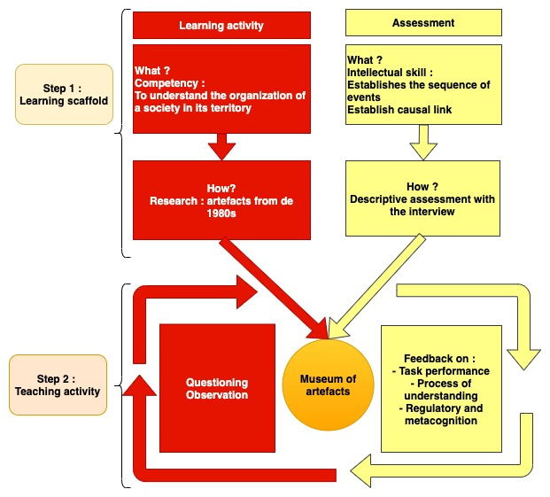
Figure 2: Interview to Assess History

Notes:
1- The article must not exceed 15 PAGES of this size specified in the form.
2- Every article that does not respect this template will be unacceptable in the form.

Corresponding author : ………………… Authors’ ORCID ID

